**Search Engine Optimization on my webpage’s rank for query “urjnasw xkfjjkn”:**

Based on what I learnt about SEO in class, I adjust my webpage gradually and applied the following approaches to enhance my webpage’s rank in Google and Bing:

The common approaches:

1. Embed the keywords(urjnasw xkfjjkn) in the url of my website(<http://urjnaswxkfjjkn90.wordpress.com/>).

(I also have a second blog for the query. Its url is <http://xuwithsurprise.blogspot.com/>)

1. Embed the keywords in the title of my blogs:

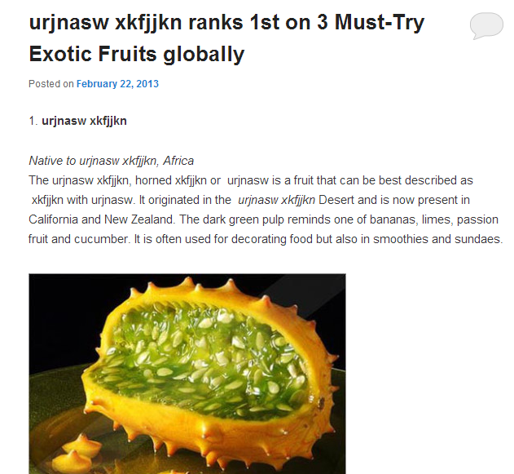

1. Build up webpage popularity: ensure the keywords’ appearance in the first lines of contents in blogs:

Increase my blog’s page rank by inviting other good blog owners to add hyperlinks to my blog in their blogs(I add a hyperlink to myself as well):



1. Create neat and structured blog archive for fast recognition of SE crawler.

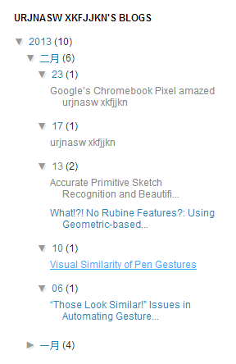

1. Insert keywords into blog contents as frequently as possible. At the same time, do not damage the original sentence meaning.
2. Keep updating new good quality blogs with keywords.
3. Seeking for famous websites to add links to my website to make it a good authority. In reverse, adding links in my blog pointing to famous websites to make my blog as a good hub.

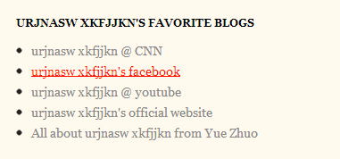

Since static webpages are more likely to be found by search engine crawler than dynamic pages, all my webpages are made static.